Lecture XV
Muscle relaxant preparations
Agents that block the transmission of ACh at the motor end plate are called neuromuscular blocking agents. The therapeutic use of these compounds is primarily as adjuvants in surgical anesthesia to obtain relaxation of skeletal muscle. They also are used in various orthopedic procedures, such as alignment of fractures and correction of dislocations. The therapeutically useful compounds in this group sometimes are referred to as possessing curariform or curarimimetic activity in reference to the original representatives of the class, which were obtained from curare. Since then, synthetic compounds have been prepared with similar activity. Although all of the compounds falling into this category, natural and synthetic alike, bring about substantially the same end result (i.e., voluntary-muscle relaxation), there are some significant differences in mechanisms.
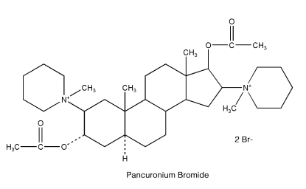
The possible existence of a junction between muscle and nerve was suggested as early as 1856, when Claude Bernard observed that the site of action of curare was neither the nerve nor the muscle. Since that time, it has been agreed that ACh mediates transmission at the neuromuscular junction by a sequence of events described previously in this chapter. The neuromuscular junction consists of the axon impinging onto a specialized area of the muscle known as the muscle end plate. The axon is covered with a myelin sheath, containing the nodes of Ranvier, but is bare at the ending. The nerve terminal is separated from the end plate by a gap of 200 Å. The subsynaptic membrane of the end plate contains the cholinergic receptor, the ion-conducting channels (which are opened under the influence of ACh), and AChE. One of the anatomical differences between the neuromuscular junction and other ACh-responsive sites is the absence in the former of a membrane barrier or sheath that envelopes the ganglia or constitutes the blood-brain barrier. This is important in the accessibility of the site of action to drugs, particularly quaternary ammonium compounds, because they pass through living membranes with considerably greater difficulty and selectivity than do compounds that can exist in a nonionized species. The essentially bare nature (i.e., lack of lipophilic barriers) of the myoneural junction permits ready access by quaternary ammonium compounds. In addition, compounds with considerable molecular dimensions are accessible to the receptors in the myoneural junction. As a result of this property, variations in the chemical structure of quaternaries have little influence on the potential ability of the molecule to reach the cholinergic receptor in the neuromuscular junction. Thus, the following types of neuromuscular junction blockers have been noted. Nondepolarizing Blocking Agents Traditionally, nondepolarizing blocking agents is a term applied to categorize drugs that compete with ACh for the recognition site on the nicotinic receptor by preventing depolarization of the end plate by the neurotransmitter. Thus, by decreasing the effective ACh–receptor combinations, the end plate potential becomes too small to initiate the propagated action potential. This results in paralysis of neuromuscular transmission. The action of these drugs is quite analogous to that of atropine at the muscarinic receptor sites of ACh. Many experiments suggest that the agonist (ACh) and the antagonist compete on a one-toone basis for the end plate receptors. Drugs in this class are tubocurarine, dimethyltubocurarine, pancuronium, and gallamine. Depolarizing Blocking Agents Drugs in the category of depolarizing blocking agents depolarize the membrane of the muscle end plate. This depolarization is quite similar to that produced by ACh itself at ganglia and neuromuscular junctions (i.e., its so-called nicotinic effect), with the result that the drug, if in sufficient concentration, eventually will produce a block. Either smooth or voluntary muscle, when challenged repeatedly with a depolarizing agent, eventually becomes insensitive. This phenomenon is known as tachyphylaxis, or desensitization, and is demonstrated convincingly under suitable experimental conditions with repeated applications of ACh itself, the results indicating that within a few minutes the end plate becomes insensitive to ACh. These statements may imply that a blocking action of this type is clear-cut, but under experimental conditions, it is not quite so unambiguous, because a block that begins with depolarization may regain the polarized state even before the block. Furthermore, depolarization induced by increasing the potassium ion concentration does not prevent impulse transmission. For these and other reasons, it is probably best to consider the blocking action a desensitization until a clearer picture emerges. Drugs falling in this class are decamethonium and succinylcholine. Curare and Curare Alkaloids Originally curare was a term used to describe collectively the very potent arrow poisons used since early times by the South American Indians. The arrow poisons were prepared from numerous botanic sources and often were mixtures of several different plant extracts. Some were poisonous by virtue of a convulsant action and others by a paralyzant action. Only the latter type is of value in therapeutics and is spoken of ordinarily as curare. Chemical investigations of the curares were not especially successful because of difficulties in obtaining authentic samples with definite botanic origin. Not until 1935 was a pure crystalline alkaloid, d-tubocurarine chloride, possessing in great measure the paralyzing action of the original curare, isolated from a plant. Wintersteiner and Dutcher,92 in 1943, isolated the same alkaloid. They showed, however, that the botanic source was Chondodendron tomentosum (Menispermaceae) and, thus, provided a known source of the drug. Following the development of quantitative bioassay methods for determining the potency of curare extracts, a purified and standardized curare was developed and marketed under the trade name Intocostrin (purified C. tomentosum extract), the solid content of which consisted of almost one-half ()-tubocurarine solids. Following these essentially pioneering developments, ()-tubocurarine chloride and dimethyltubocurarine iodide appeared on the market as pure entities. Tubocurarine Chloride, USP. Tubocurarine chloride, ()-tubocurarine chloride hydrochloride pentahydrate, is prepared from crude curare by a process of purification and crystallization. Tubocurarine chloride occurs as a white or yellowish white to grayish white, odorless, crystalline powder that is soluble in water. Aqueous solutions of it are stable to heat sterilization. The structural formula for ()-tubocurarine was long thought to be that of Ia (see structure diagram). Through the work of Everett et al.,93 the structure is now known to be that of Ib. The monoquaternary nature of Ib thus revealed has caused some reassessment of thinking concerning the theoretical basis for the blocking action, because all had previously assumed a diquaternary structure (i.e., Ia). Nevertheless, this does not negate the earlier conclusions that a diquaternary nature of the molecule provides better blocking action than does a monoquaternary nature (e.g., Ib is approximately fourfold less potent than dimethyl tubocurarine iodide).
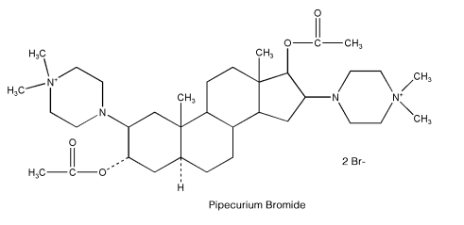
Further, ()- isotubocurarine chloride (Ic) has twice the activity of Ib in the particular test used. Tubocurarine is a nondepolarizing blocking agent used for its paralyzing action on voluntary muscles, the site of action being the neuromuscular junction. Its action is inhibited or reversed by the administration of AChE inhibitors, such as neostigmine, or by edrophonium chloride (Tensilon). Such inhibition of its action is necessitated in respiratory embarrassment caused by overdosage. Additionally, in somewhat higher concentrations, dtubocurarine may enter the open ion channel and add a noncompetitive blockade. Cholinesterase inhibitors do not restore this latter action easily or fully. Often, adjunctive artificial respiration is needed until the maximal curare action has passed. The drug is inactive orally because of inadequate absorption through lipoidal membranes in the GI tract, and when used therapeutically, it usually is injected intravenously. d-Tubocurarine binds for only 1 ms to the receptor, yet its pharmacological effect of muscle paralysis, produced by administration of the drug intravenously during surgery, lasts for up to 2 hours. The basis of this action is the pharmacokinetics of the drug. d-Tubocurarine is given intravenously, and although 30% to 77% is bound to plasma proteins, the drug is distributed rapidly to central body compartments, including neuromuscular junctions. About 45% of d-tubocurarine is eliminated unchanged by the kidneys. Its half-life is 89 minutes. Tubocurarine, in the form of a purified extract, was used first in 1943 as a muscle relaxant in shock therapy for mental disorders. Its use markedly reduced the incidence of bone and spine fractures and dislocations from convulsions because of shock. Following this, it was used as an adjunct in general anesthesia to obtain complete muscle relaxation, a use that persists to this day. Before its use began, satisfactory muscle relaxation in various surgical procedures (e.g., abdominal operations) was obtainable only with “deep” anesthesia with the ordinary general anesthetics. Tubocurarine permits a lighter plane of anesthesia, with no sacrifice in the muscle relaxation so important to the surgeon. A reduced dose of tubocurarine is administered with ether because ether itself has curare-like action. Metocurine Iodide, USP. Metocurine iodide, ()- O,O-dimethylchondrocurarine diiodide (Metubine iodide), is prepared from natural crude curare by extracting the curare with methanolic potassium hydroxide. When the extract is treated with an excess of methyl iodide, the ()- tubocurarine is converted to the diquaternary dimethyl ether and crystallizes out as the iodide (see “Tubocurarine Chloride”). Other ethers besides the dimethyl ether have been made and tested. For example, the dibenzyl ether was one third as active as tubocurarine chloride, and the diisopropyl compound had only one half the activity. For comparison, the dimethyl ether has approximately 4 times the activity of tubocurarine chloride. The pharmacological action of this compound is the same as that of tubocurarine chloride, namely, a nondepolarizing competitive blocking effect on the motor end plate of skeletal muscles. It is considerably more potent than d-tubocurarine, however, and has the added advantage of exerting much less effect on respiration. The effect on respiration is not a significant factor in therapeutic doses. Accidental overdosage is counteracted best by forced respiration. Synthetic Compounds with Curariform Activity Curare, until relatively recent times, remained the only useful curarizing agent; and it, too, suffered from a lack of standardization. The original pronouncement in 1935 of the structure of ()-tubocurarine chloride, unchallenged for 35 years, led other workers to hope for activity in synthetic substances of less complexity. The quaternary ammonium character of the curare alkaloids coupled with the known activity of the various simple onium compounds hardly seemed to be coincidental, and it was natural for research to follow along these lines. One of the synthetic compounds discovered was marketed in 1951 as Flaxedil (gallamine triethiodide). Other various neuromuscular blocking agents have followed. Atracurium Besylate. Atracurium besylate, 2-(2-carboxyethyl)-1,2,3,4-tetrahydro-6,7-dimethoxy-2-methyl-1- veratrylisoquinolinium benzenesulfonate pentamethylene ester (Tracrium), is a nondepolarizing neuromuscular blocking agent that is approximately 2.5 times more potent than d-tubocurarine. Its duration of action (half-life, 0.33 hours) is much shorter than that of d-tubocurarine. The drug is metabolized rapidly and nonenzymatically to yield laudanosine and a smaller quaternary compound which do not have neuromuscular blocking activity.
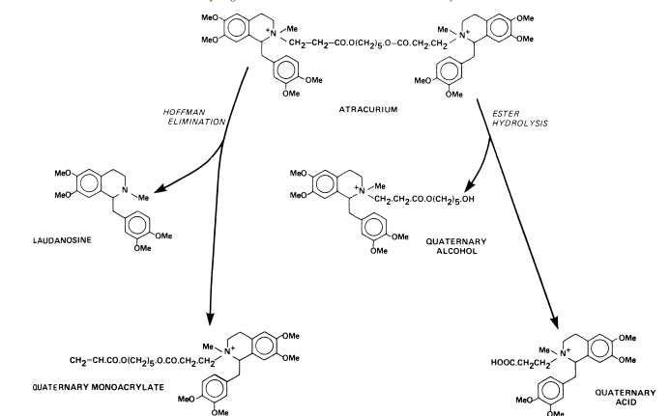
In vitro experiments show that atracurium besylate breaks down at pH 7.4 and 37°C by a Hoffman elimination reaction.94 Atracurium besylate undergoes enzymatic decomposition of its ester function to yield an inactive quaternary alcohol and quaternary acid. AChE inhibitors such as neostigmine, edrophonium, and pyridostigmine antagonize paralysis by atracurium besylate. Doxacurium Chloride. The molecular structure of doxacurium chloride, 1,2,3,4-tetrahydro-2-(3-hydroxypropyl)- 6,7,8-trimethoxy2-methyl-1-(3,4,5-trimethoxybenzyl) isoquinolinium chloride succinate (Nuromax), provides the possibility for 10 stereoisomers: 4 d,l pairs and two meso forms. Of the 10 stereoisomers, 3 are all-trans configuration, and these are the only active ones.95 Doxacurium chloride is a long-acting nondepolarizing blocking agent. The drug differs from drugs such as gallium and pancuronium in that it has no vagolytic activity. It is used as a skeletal muscle relaxant in surgical procedures expected to last longer than 90 minutes. Gallamine Triethiodide, USP. Gallamine triethiodide, [v-phenenyl-tris(oxyethylene)]tris[triethylammonium] triiodide (Flaxedil), is a skeletal muscle relaxant that works by blocking neuromuscular transmission in a manner similar to that of d-tubocurarine (i.e., a nondepolarizing blocking agent). It does have some differences, however. It has a strong vagolytic effect and a persistent decrease in neuromuscular function after successive doses that cannot be overcome by cholinesterase inhibitors.
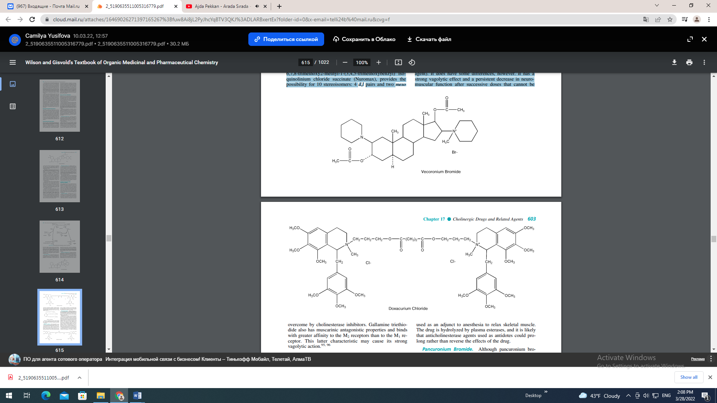

Gallamine triethiodide also has muscarinic antagonistic properties and binds with greater affinity to the M2 receptors than to the M1 receptor. This latter characteristic may cause its strong vagolytic action.

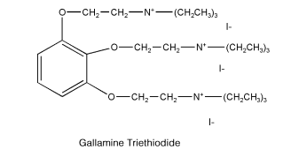
The drug is contraindicated in patients with myasthenia gravis, and one should remember that its action is cumulative, as with curare. The antidote for gallamine triethiodide is neostigmine. Mivacurium Chloride. Mivacurium chloride, 1,2,3,4- tetrahydro-2-(3-hydroxypropyl)-6,7-dimethoxy-2-methyl1-(3,4,5-trimethoxybenzyl)isoquinolinium chloride, (E)-4- octandioate (Mivacron), is a mixture of three stereoisomers, the trans-trans, cis-trans, and cis-cis diesters, each of which has neuromuscular blocking properties. The cis-cis isomer is about one tenth as potent as the other isomers. Mivacurium chloride is a short-acting nondepolarizing drug used as an adjunct to anesthesia to relax skeletal muscle. The drug is hydrolyzed by plasma esterases, and it is likely that anticholinesterase agents used as antidotes could prolong rather than reverse the effects of the drug. Pancuronium Bromide. Although pancuronium bromide, 2,16-dipiperidino-5-androstane-3,17-diol diacetate dimethobromide (Pavulon), is a synthetic product, it is based on the naturally occurring alkaloid malouetine, found in arrow poisons used by primitive Africans. Pancuronium bromide acts on the nicotinic receptor and in the ion channel, inhibiting normal ion fluxes. This blocking agent is soluble in water and is marketed in concentrations of 1 or 2 mg/mL for intravenous administration. It is a typical nondepolarizing blocker, with a potency approximately 5 times that of ()-tubocurarine chloride and a duration of action approximately equal to the latter. Studies indicate that it has little or no histamine-releasing potential or ganglion-blocking activity and that it has little effect on the circulatory system, except for causing a slight rise in the pulse rate. As one might expect, ACh, anticholinesterases, and potassium ion competitively antagonize it, whereas its action is increased by inhalation anesthetics such as ether, halothane, enflurane, and methoxyflurane. The latter enhancement in activity is especially important to the anesthetist because the drug is frequently administered as an adjunct to the anesthetic procedure to relax the skeletal muscle. Perhaps the most frequent adverse reaction to this agent is occasional prolongation of the neuromuscular block beyond the usual time course, a situation that can usually be controlled with neostigmine or by manual or mechanical ventilation, since respiratory difficulty is a prominent manifestation of the prolonged blocking action.

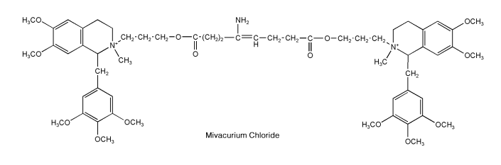
As indicated, the principal use of pancuronium bromide is as an adjunct to anesthesia, to induce relaxation of skeletal muscle, but it is also used to facilitate the management of patients undergoing mechanical ventilation. Only experienced clinicians equipped with facilities for applying artificial respiration should administer it, and the dosage should be adjusted and controlled carefully. Pipecurium Bromide. Pipecurium bromide, 4,4-(3, 17-dihydroxy-5-androstan-2,16-ylene)bis(1,1- dimeth-ylpiperazinium)dibromide diacetate (Arduan), is a nondepolarizing muscle relaxant similar, both chemically and clinically, to pancuronium bromide. It is a long-acting drug indicated as an adjunct to anesthesia and in patients undergoing mechanical ventilation. Vecuronium Bromide. Vecuronium bromide, 1-(3, 17-dihydroxy-2-piperidino-5-androstan-16-yl)-1- methylpiperidinium bromide diacetate (Norcuron), is the monoquaternary analog of pancuronium bromide. It belongs to the class of nondepolarizing neuromuscular blocking agents and produces effects similar to those of drugs in this class. It is unstable in the presence of acids and undergoes gradual hydrolysis of its ester functions in aqueous solution. Aqueous solutions have a pH of about 4.0. This drug is used mainly to produce skeletal muscle relaxation during surgery and to assist in controlled respiration after general anesthesia has been induced.
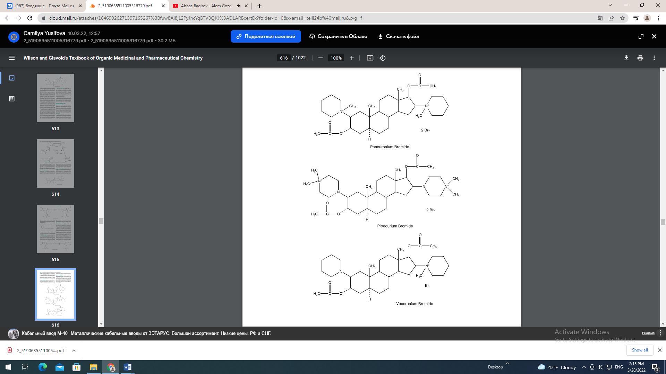
Succinylcholine Chloride, USP. Succinylcholine chloride, choline chloride succinate (2:1) (Anectine, Sucostrin), is a white, odorless, crystalline substance that is freely soluble in water to give solutions with a pH of about 4. It is stable in acidic solutions but unstable in alkali. Aqueous solutions should be refrigerated to ensure stability. Succinylcholine chloride is characterized by a very short duration of action and a quick recovery because of its rapid hydrolysis after injection. It brings about the typical muscular paralysis caused by blocking nervous transmission at the myoneural junction. Large doses may cause temporary respiratory depression, as with similar agents. Its action, in contrast with that of (1)-tubocurarine, is not antagonized by neostigmine, physostigmine, or edrophonium chloride. These anticholinesterase drugs actually prolong the action of succinylcholine chloride, which suggests that the drug is probably hydrolyzed by cholinesterases. The brief duration of action of this curare-like agent is said to render an antidote unnecessary if the proper supportive measures are available. Succinylcholine chloride has a disadvantage, however, in that the usual antidotes cannot terminate its action promptly. It is used as a muscle relaxant for the same indications as other curare agents. It may be used for either short or long periods of relaxation, depending on whether one or several injections are given. In addition, it is suitable for continuous intravenous drip administration. Succinylcholine chloride should not be used with thiopental sodium because of the high alkalinity of the latter. If used together, they should be administered immediately after mixing; however, separate injection is preferable.

